From motor datasheet:

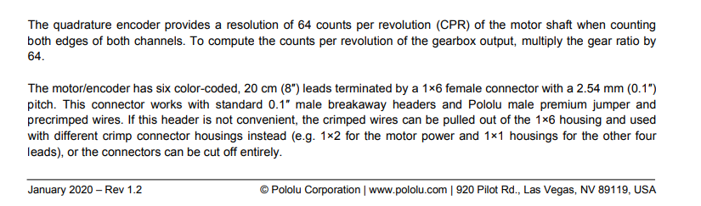

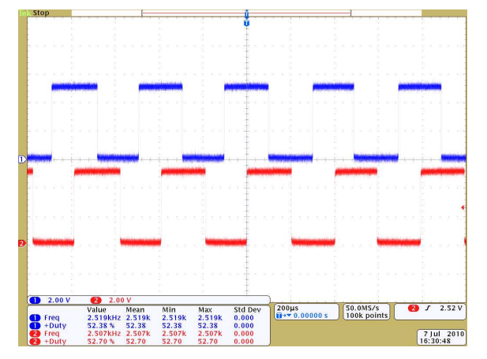

E.g.

* 64 counts in rising and falling edge of both channels
* 32 counts rising edge channel one + falling edge channel 2 (180 out of phase)
* 16 counts in rising edge of one channel

**Rising Edge one channel:**

$\frac{1 Rev_{M}}{16 pulse}* \frac{1 Rev_{G}}{10 Rev_{M}}*\frac{15 teeth}{1 Rev_{G}}*\frac{1 Rev_{O}}{100 teeth}*\frac{360°}{1 Rev_{O}}=0.3375 °/pulse$

**Rising Edge channel one + falling edge channel 2 (180 out of phase):**

$\frac{1 Rev_{M}}{32 pulse}* \frac{1 Rev_{G}}{10 Rev_{M}}*\frac{15 teeth}{1 Rev_{G}}*\frac{1 Rev_{O}}{100 teeth}*\frac{360°}{1 Rev_{O}}=0.16875 °/pulse$

**Rising and falling edge of both channels**

$\frac{1 Rev_{M}}{64 pulse}* \frac{1 Rev_{G}}{10 Rev_{M}}*\frac{15 teeth}{1 Rev_{G}}*\frac{1 Rev_{O}}{100 teeth}*\frac{360°}{1 Rev_{O}}=0.084375 °/pulse$

* RevM: Revolution of motor shaft
* RevG: Revolution of gearbox output
* RevO: Revolution of outer gear